System Software (CS306)

Assignment - 3

**U20CS135**

**1. Write a C program to recognize strings under ‘a*’, ‘a*b+’.**

#include<bits/stdc++.h>

using namespace std;

void jaiishriram(string s)

{

  map<char,int>m;

    int n=s.length();

    for(int i=0;i<n;i++)

    {

         m[s[i]]++;

    }

    if(m['a']==n)

    {

        cout<<"String Recognized and it is a*"<<endl;

*return*;

    }

    else if(m.size()<=2)

    {

        string k=s;

        sort(k.begin(),k.end());

        if(k==s)

        {

           cout<<"String Recognized and it is a*b+"<<endl;

*return*;

        }

    }

    cout<<"String not Recognized"<<endl;

}

int main()

{

    string s;

    cin>>s;

    jaiishriram(s);

*return* 0;

}

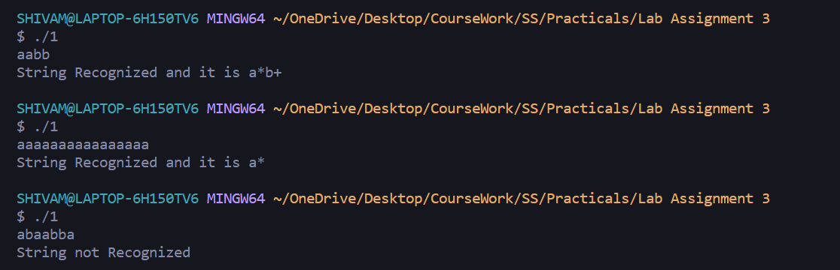

**SUBMITTED BY**:

U20CS135

Shivam Mishra